

MACHINE LEARNING FUNDAMENTALS

PROJECT REPORT

NAME: Bilal Shabbir (SP24-BDS-011)

SECTION: BDS-4A

SUBMITTED TO: DR. JAVED IQBAL

PROBLEM IDENTIFICATION

PREDICTING HOUSE PRICE USING ML REGRESSION TECHNIQUES.

OBJECTIVE

This project builds a complete machine learning regression pipeline to predict median house values based on socio-economic, household, and geographic characteristics of California census block groups. The workflow includes data loading, exploratory data analysis (EDA), descriptive statistical analysis, outlier detection and treatment, preprocessing pipelines, model training using Linear Regression, Decision Tree Regressor, and Random Forest Regressor, model evaluation using multiple regression metrics, feature importance analysis, and result interpretation.

RECOMMENDED DATASET:

The California Housing dataset is used for this task.

PHASE 1: Understanding the Dataset & Basic EDA

The dataset contains 45,211 records and 17 features, including both numerical and categorical variables. The California Housing dataset is used for this task.
- The dataset contains 20,640 records and 9 numerical features, representing aggregated information at the census block-group level.
- All variables are numerical, making the dataset suitable for regression-based machine learning models.
Target Variable: MedHouseVal — indicates Median house value for a block group, which is capped at an upper limit.

Despite its popularity, the dataset has several important limitations.
- The target variable is capped at an upper limit, causing a ceiling effect that makes high-value areas difficult to model accurately.
- Since the data is aggregated rather than individual-house level, it cannot capture micro-level housing details.
- Many features are highly skewed and ratio-based, which can introduce outliers and interpretation issues without proper preprocessing.
- Additionally, key housing attributes such as property size, condition, and access to amenities are missing.

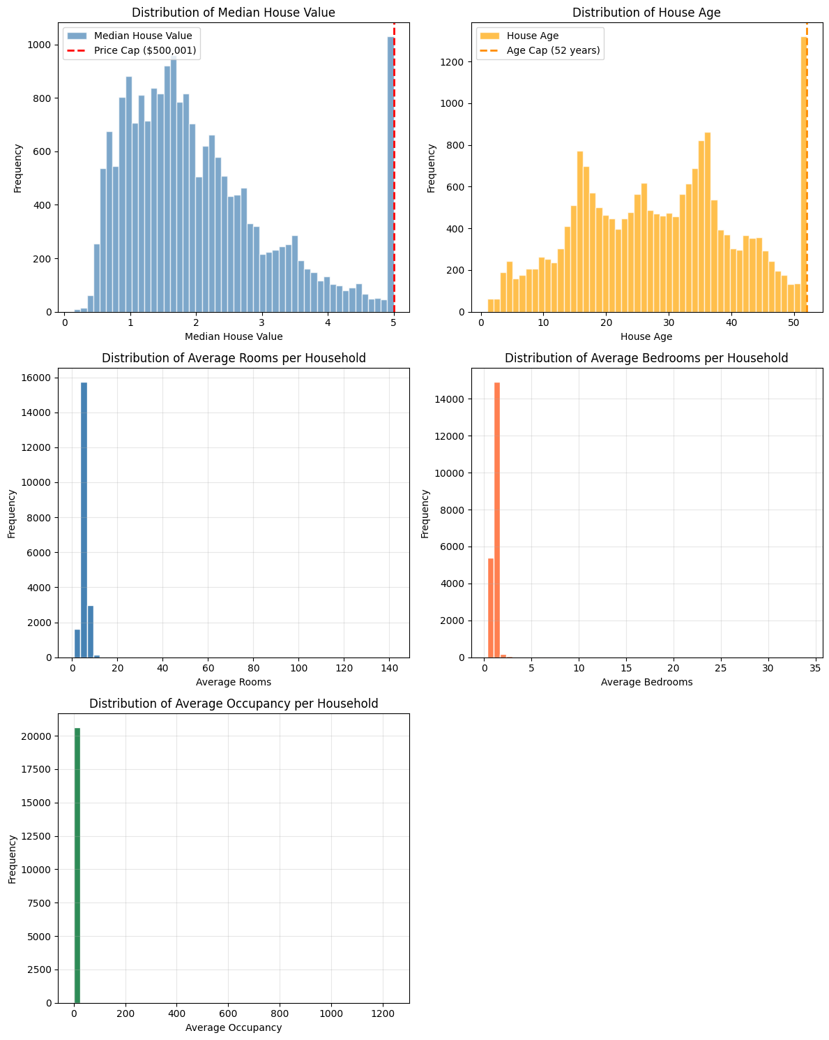

PHASE 2: Data Preprocessing

No null values were found but outliers were identified and treated.

Clipping, Log Transformation and Z-Score standardization techniques were utilized to treat the outliers.

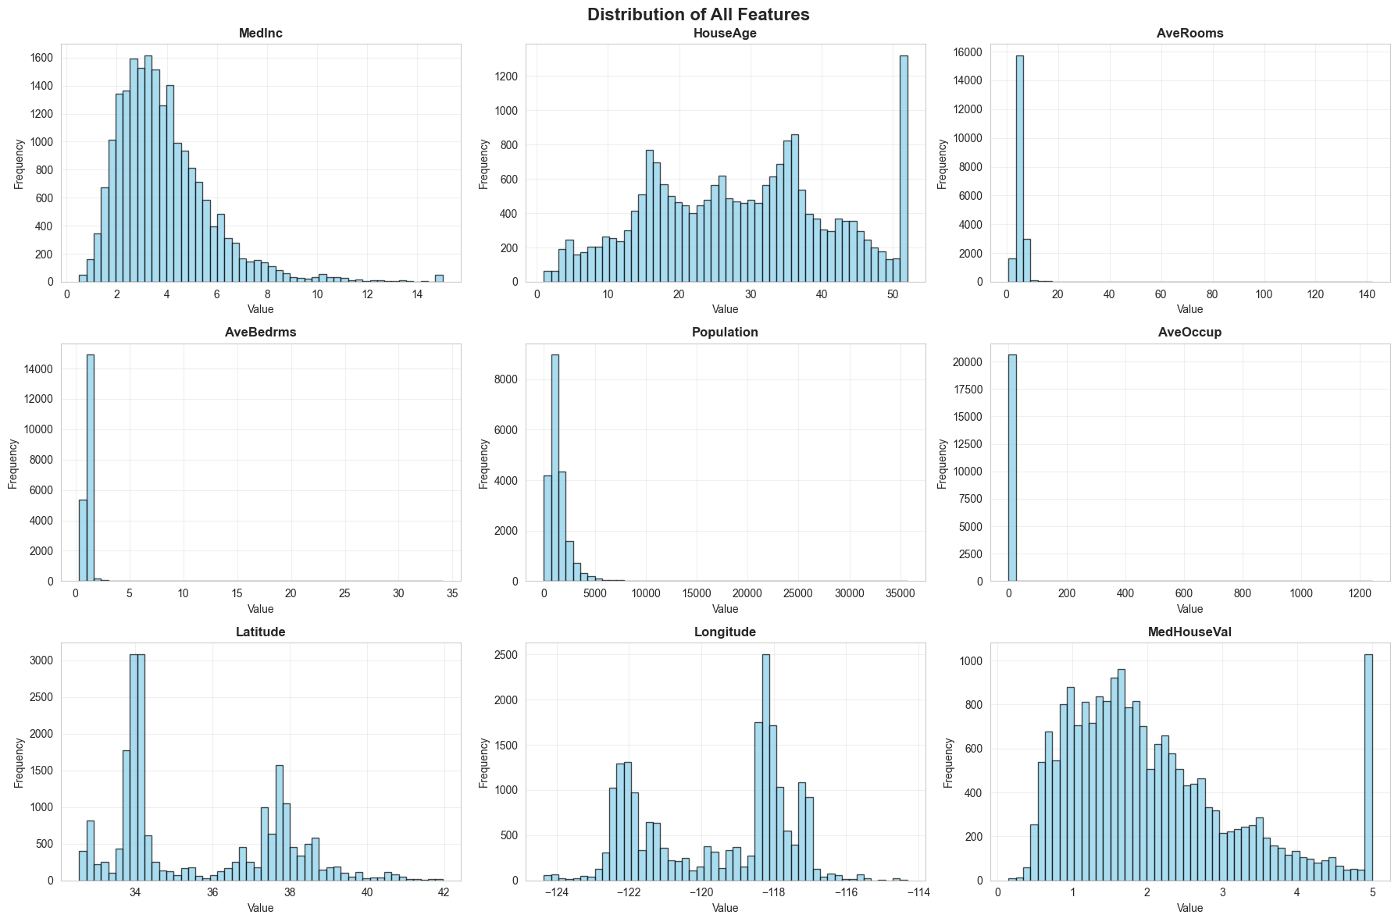

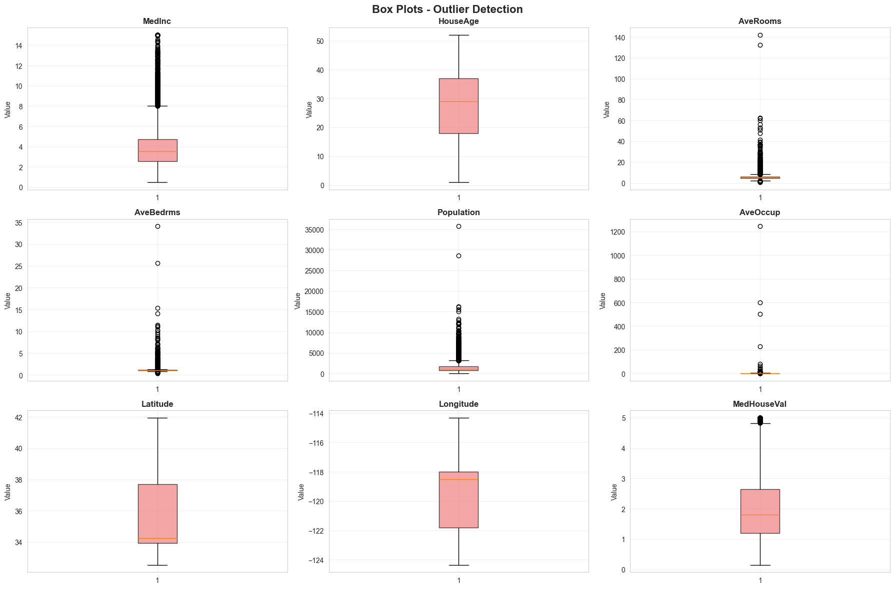

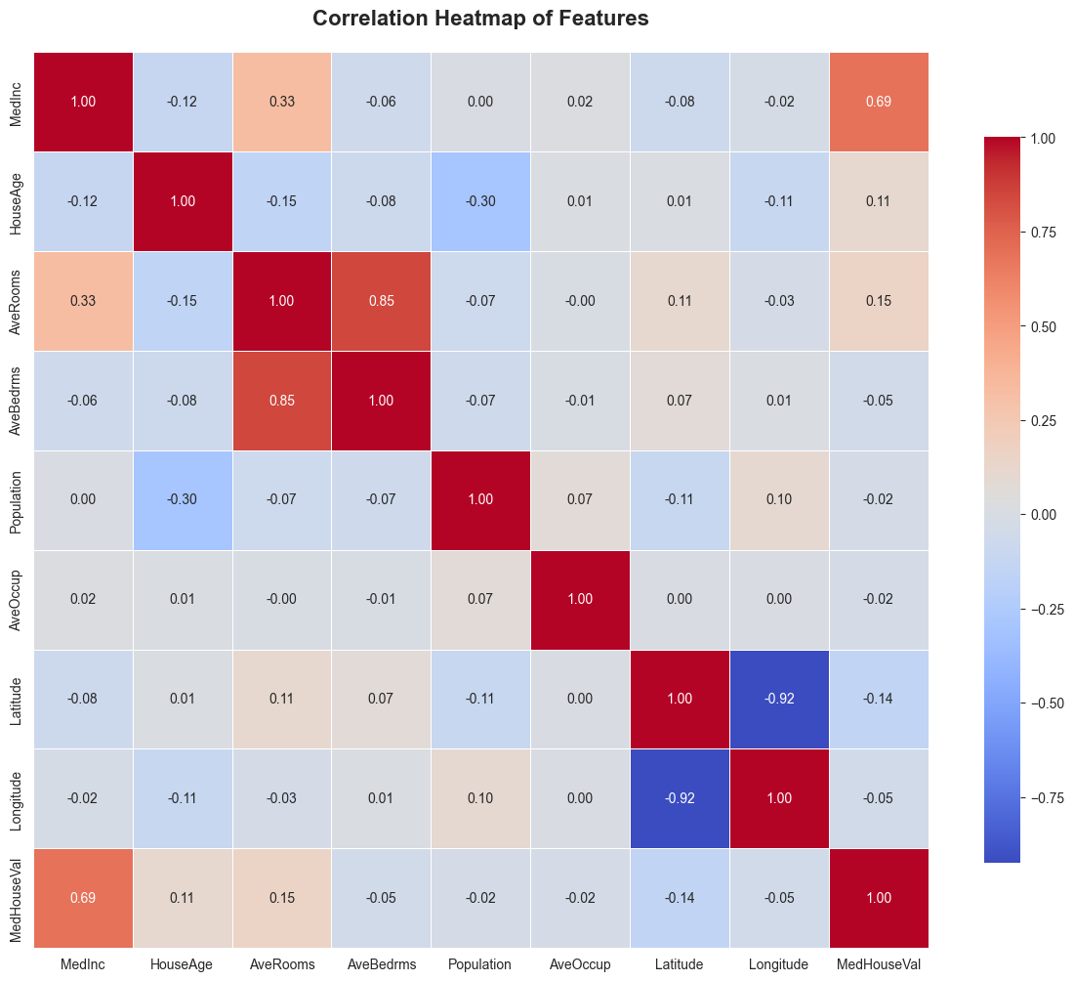

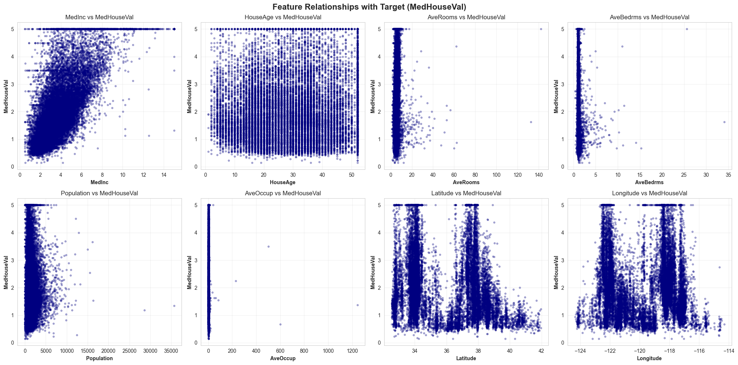

PHASE 3: Model Development
Model | Relationship | Outlier Sensitivity | Interpretability
Linear Regression | Linear | High | High
Decision Tree | Non-linear | Medium | Medium
Random Forest | Non-linear ensemble | Low | Medium-Low

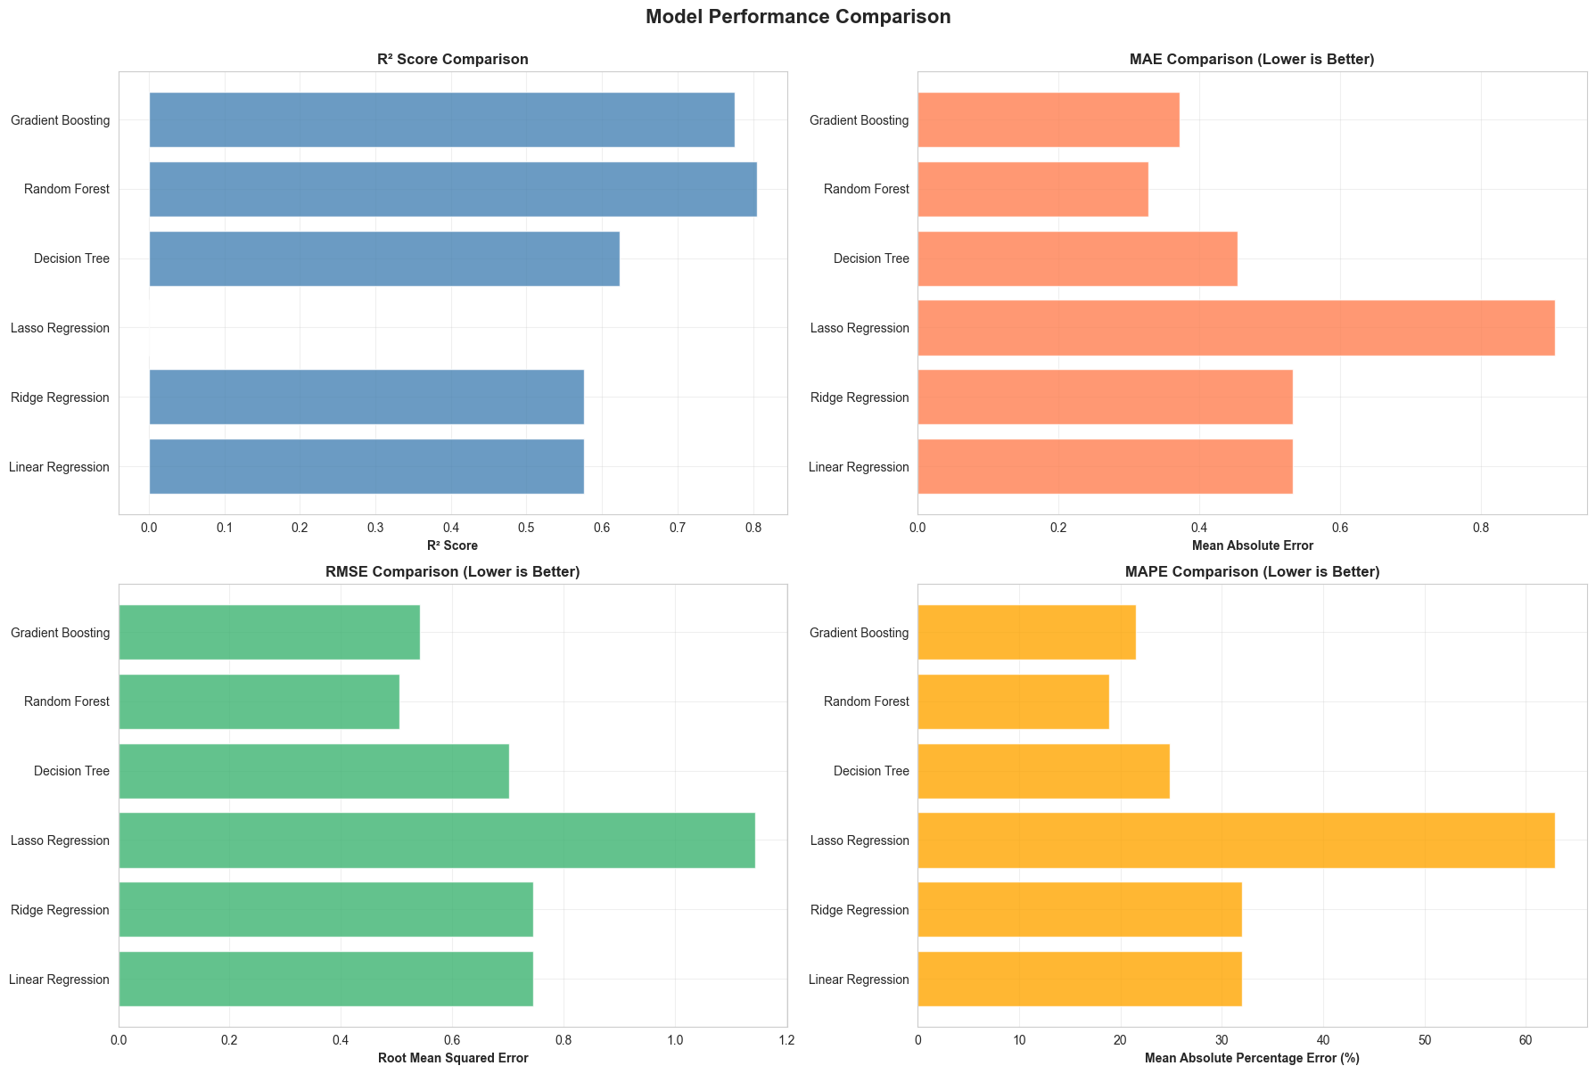

Conclusion:
- Random Forest is the best baseline for this dataset.
- Linear models are limited by skewed ratios and non-linear interactions.

Feature Importance

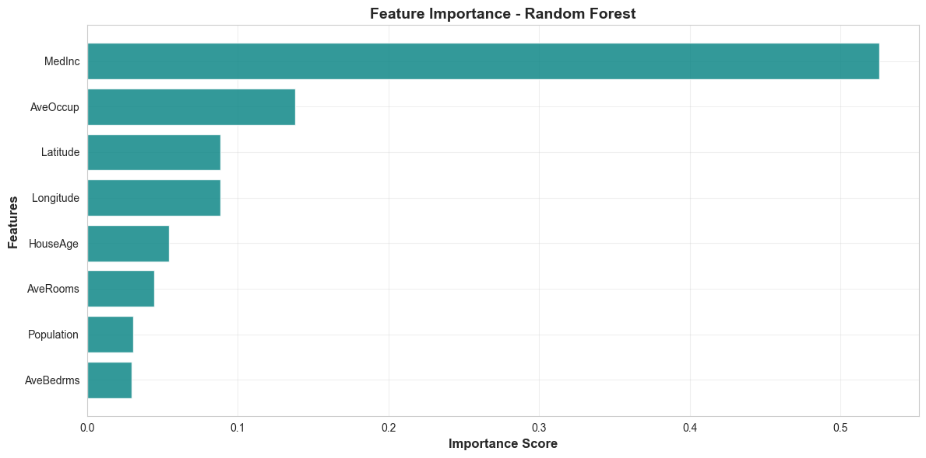

Why these make sense?
- High MedInc → High house prices (direct economic relationship)
- AveOccup → Overcrowded areas may lower price per household
- Latitude/Longitude → Coastal premium, urban vs rural differences
- AveRooms & HouseAge → Capture home quality and size
- Population → Only indirectly related

PHASE 4: Final Model & Deployment

- Random Forest emerged as the best-performing model, having the lowest errors (MAE, MSE RMSE) and R² of 0.805, meaning it explains about 80% of the variance in the house values.
  - RF is robust to remaining skewness and outliers and averages across multiple trees, reducing overfitting.
  - Random Forest offers a good balance: strong predictive power + feature importance insights.

Aspect | Interpretation
Accuracy | Strong (tight actual vs predicted alignment)
Bias | Minimal (residuals centered at zero)
Variance | Controlled (few extreme errors)

